Kickstarter Campaign

# Analysis:

What are three conclusions we can make about Kickstarter campaigns given the provided data?

* Most successful category of the campaign was Theater and less impactful was journalism
* Most successful sub-category was Play with close to 700 successful outcome.
* Maximum number of successful participation at 1,000 to 5,000 level goal with over 900 successful outcomes.

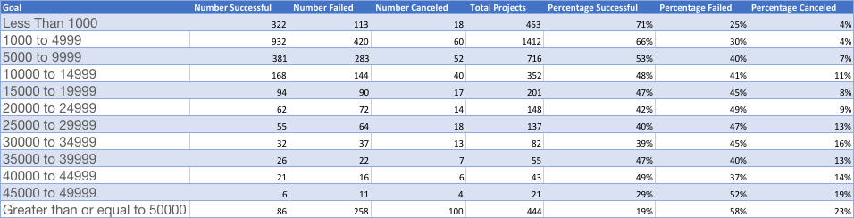

# Limitation of Dataset

* Currencies not converted into US dollars making them hard to compare by segment/country for the campaign
* Some of the goals were too aggressive with lots of cancellation/failed results. There was no detail provided on reasons for cancellations to do more analysis
* The dataset is combination of multiple types of campaign which makes them hard to comoare

# Other possible types of tables:

* Create profile by country to identify the most successful segment
* Perform analysis on number of backers and average donation to maximize the potential of successful campaign
* Correlation of goal and the outcome of the campaign to indicate the best type of combination.